**TVET DISTRICT COMPREHENSIVE ASSESSMENT**

**SCHOOL YEAR 2022-2023**

**GASABO DISTRICT**

**SECTOR: INFORMATION COMMUNICATION AND TECHNOLOGY (ICT)**

**TRADE: SOFTWARE DEVELOPMENT**

**RTQF LEVEL: IV**

**MODULE CODE AND TITLE: SFDSF401, BASICS AND FUNDAMENTALS OF DATABASE**

**DURATION: 3HOURS**

**DATE:**

**INSTRUCTION TO CANDIDATES:**

**Instructions: This Assessment Consists three (3) sections A, B and C**

**Section A: All questions are compulsory. 55marks**

**Section B: Attempt any 3 questions. 30marks**

**Section C: Choose only one (1) question 15 marks**

**SECTION A: ATTEMPT ALL QUESTIONS 55marks**

**Q1.** Define the following term:**/5marks**

**a.** Data  **b**. database **c**. Entities **d**. attributes **e.** information

**References:** SFDSFD401, BASICS AND FUNDAMENTALS OF DATABASE learning unit 1: Analyze database requirement, Learning Outcome1.1: Define database key terms, models, types and relationships, page 266.

**Q2.** List 3 types of relationships. **/5marks**

**References:** SFDSFD401, BASICS AND FUNDAMENTALS OF DATABASE learning unit 1: analyze database requirement, Learning Outcome1.1: Define database key terms, models, types and relationships, page 266.

**Q3.** Choose the correct answer for the following sentence**/5marks**

Which SQL statement is used to add new data or record in a database?

1. Top of Form
2. INSERT INTO
3. ADD NEW
4. INSERT NEW
5. ADD RECORD

**References:** SFDSFD401, BASICS AND FUNDAMENTALS OF DATABASE Learning unit 3: Create Database, Learning Outcome 3.1: Create tables and attributes.

**Q4.** Outline any four different types of database model  **/5Marks**

**References:** SFDSFD401, BASICS AND FUNDAMENTALS OF DATABASE learning unit 1: analyze database requirement, Learning Outcome1.1: Define database key terms, models, types and relationships.

**Q5**. Define constraints. List and explain types of constraints **/5marks**

**References:** SFDSFD401, BASICS AND FUNDAMENTALS OF DATABASE learning unit 2: Design database, Learning Outcome 2.2: Identify the constraints.

**Q6.**Complete the description column in this table based each DB constraints**/5marks**

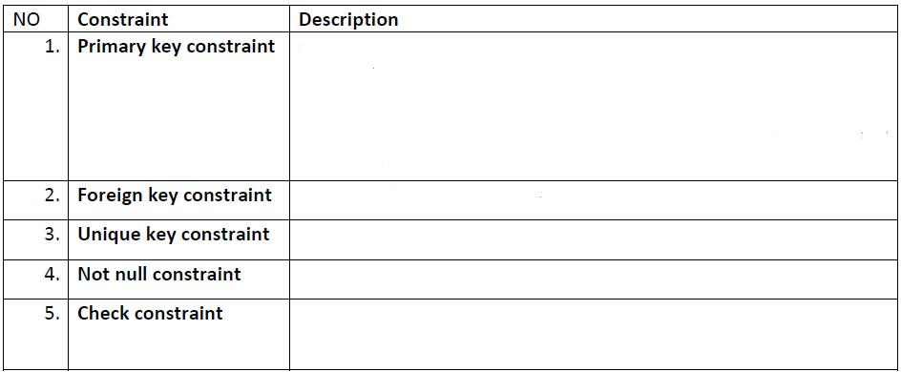

**References:** SFDSFD401, BASICS AND FUNDAMENTALS OF DATABASE learning unit 2: Design database, Learning Outcome 2.2: Identify the constraints.

**Q7.** Explain the terms ‘Record’, ‘Field’ and ‘Table’ in terms of database. **/5marks**

**References:** SFDSFD401, BASICS AND FUNDAMENTALS OF DATABASE learning unit 1: analyze database requirement, Learning Outcome 1.3: Determine the information that the database is required to hold.

**Q8.** Differentiate primary key and foreign key**/5marks**

**References:** SFDSFD401, BASICS AND FUNDAMENTALS OF DATABASE learning unit 2: Design database, Learning Outcome 2.2: Identify the constraints.

**Q9.** Give any five objectives of database management system **/5marks**

**References:** SFDSFD401, BASICS AND FUNDAMENTALS OF DATABASE learning unit 2: Design database, Learning Outcome 2.3: Develop a data dictionary.

**Q10.** Give any five advantages of database management system **/5marks**

**References:** SFDSFD401, BASICS AND FUNDAMENTALS OF DATABASE learning unit 2: Design database, Learning Outcome 2.3: Develop a data dictionary.

**Q11.** Identify and explain 3 methods used to collect the information. **/5marks**

**References:** SFDSFD401, BASICS AND FUNDAMENTALS OF DATABASE learning unit 1: analyze database requirement, Learning Outcome1.2: Review organizational and task requirements to identify user requirement.

**SECTION B: ATTEMPT ALL QUESTIONS 30marks**

**Q12.** Write syntax of how to create database by using xampp, create table with its attributes and insert new record in created table. **/10 marks**

**References:** SFDSFD401, BASICS AND FUNDAMENTALS OF DATABASE Learning unit 3: Create Database, Learning Outcome 3.1: Create tables and attributes.

**Q13.** Consider the table BOOKS below: /**10marks**

|  |  |  |  |  |  |
| --- | --- | --- | --- | --- | --- |
| Book ID | Book name | Edition | Author | Published date | Number |
| B001 | Web design | Ed2 | H.olivier | 1997 | 30 |
| B002 | Database | Ed1 | P. Albert | 2001 | 20 |
| B003 | VB | Ed3 | M.Claude | 1985 | 14 |
| B004 | Web design | Ed1 | J.Mata | 1998 | 26 |

By using the table above, write the SQL commands do the following:

1. Write SQL query to create the table BOOKS **/4marks**
2. Inserting a new record into the table BOOKS **/3marks**
3. Write SQL query to display all records from BOOKS. **/3marks**

**References:** SFDSFD401, BASICS AND FUNDAMENTALS OF DATABASE Learning unit 3: Create Database, Learning Outcome 3.1: Create tables and attributes.

**Q14.** **a.** Define entity relationship diagram(ERD)

## b. List, name and draw Common Entity Relationship Diagram Symbols **/10marks.**

**References:** SFDSFD401, BASICS AND FUNDAMENTALS OF DATABASE learning unit 2: Design database, Learning Outcome 2.1: Design an entity relationship diagram (ERD).

**Q15.** Briefly explain any five goals of DBMS. **10Marks**

**SECTION C: CHOOSE ONE QUESTION ANSWER IT.**

**Q16.** Given the following CMD and translate into LMD, before identify all entities, attributes, name of relationship between entities and their cardinalities among them.**/15marks.**

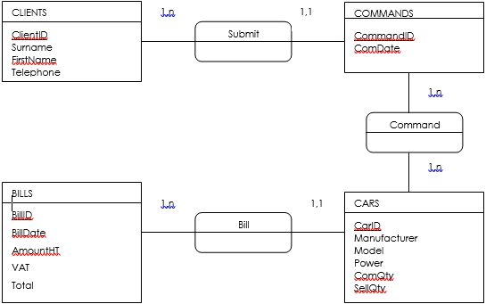

**References:** SFDSFD401, BASICS AND FUNDAMENTALS OF DATABASE learning unit 2: Design database, Learning Outcome 2.1: Design an entity relationship diagram (ERD).

**Q17. a.** Define metadata **(5marks)**

**b.** List 4 types of metadata **(5marks)**

**c.** Explain types of metadata listed in (b) **(5marks)**

**References:** SFDSFD401, BASICS AND FUNDAMENTALS OF DATABASE learning unit 2: Design database, Learning Outcome 2.1: Design an entity relationship diagram (ERD).